### FAST NUCES Lahore - Home

### TestOps Integration Report

**Title: Enhancing Software Development through TestOps Integration**

**Submitted To: Jawad Khalid**

**Submitted by: Noor Fatima**

**Date: 01/12/2024**

Table of Contents

Executive Summary 2

1. Introduction to TestOps 2

2. Current Framework Assessment 2

2.1 Overview of Existing Tools 2

2.2 Integration and Effectiveness 2

3. Identification of Gaps 3

3.1 Automation Gaps 3

3.2 Feedback Loops 3

3.3 Test Management 3

4. TestOps Tools and Solutions 3

4.1 Katalon TestOps 3

4.2 Testkube 3

5. Conclusion and Recommendations 4

6. References 4

Work Flow 5

# Executive Summary

This report explores the integration of TestOps within the DevOps practices to streamline and enhance the software development and delivery process. It examines the current testing framework, identifies gaps, and suggests tools and strategies to address these deficiencies. The ultimate goal is to facilitate a seamless, efficient, and continuous testing environment that aligns with the rapid development cycles of today's software industry.

## 1. Introduction to TestOps

TestOps is an evolutionary approach that bridges the gap between software testing and operations, embedding quality assurance into every phase of the software development lifecycle. It leverages automation, continuous testing, and strategic planning to enhance the efficiency of DevOps pipelines, ensuring that software deliveries are faster and more reliable.

## 2. Current Framework Assessment

### 2.1 Overview of Existing Tools

Our current framework utilizes a variety of tools designed to address different aspects of software testing:

* **Selenium**: Used for automated web testing.
* **JUnit**: Employed for unit testing within the Java programming environment.
* **Jenkins**: Integrates these tools into our continuous integration/continuous delivery (CI/CD) pipeline.

### 2.2 Integration and Effectiveness

While these tools are effectively integrated into our CI/CD pipeline, there are noticeable inefficiencies in real-time feedback, automation across diverse environments, and comprehensive test management.

## 3. Identification of Gaps

### 3.1 Automation Gaps

Our framework lacks a robust automation strategy across all testing phases, particularly in performance and security testing, which are crucial for early bug detection and mitigation.

### 3.2 Feedback Loops

The delay in feedback from testing to development hinders the quick resolution of identified issues, affecting the overall pace of development.

### 3.3 Test Management

The management of test cases and results is not centralized, leading to challenges in tracking and analyzing testing outcomes comprehensively.

## 4. TestOps Tools and Solutions

### 4.1 Katalon TestOps

Katalon TestOps offers an integrated platform that supports:

* Test Orchestration: Streamlining test processes across various environments.
* Real-Time Reporting: Providing immediate insights into test results, facilitating faster decision-making.
* Integration with CI/CD Tools: Seamless integration with tools like Jenkins to enhance existing workflows.

### 4.2 Testkube

Testkube excels in managing and executing tests in Kubernetes environments, offering:

* Native Kubernetes Testing: Aligns testing with modern containerized applications.
* **CI/CD Integration**: Enhances our Jenkins setup by integrating Kubernetes-native testing capabilities.

## 5. Conclusion and Recommendations

Adopting TestOps by integrating tools like Katalon TestOps and Testkube can significantly address the identified gaps in our current testing framework. These tools will streamline our testing processes, enhance real-time feedback loops, and improve our overall test management and execution strategies.

## 6. References

• **Katalon TestOps Documentation**: Provides comprehensive information on the capabilities of Katalon TestOps and its integration options. Available at: <https://docs.katalon.com/>

• **Testkube**: Offers insights into Kubernetes-native testing strategies using Testkube, enhancing CI/CD workflows. Available at: <https://testkube.io/>

• **Martin Fowler on TestOps**: A conceptual exploration of how TestOps fits within the broader DevOps culture to enhance software quality and development efficiency. Available at: <https://martinfowler.com/testing/>

• **DevOps Institute on TestOps**: Discusses the strategic importance of TestOps in modern software development practices. Available at: <https://www.devopsinstitute.com/>

• **DZone on Continuous Testing**: An article that elaborates on continuous testing as a core component of TestOps, highlighting tools and best practices. Available at: <https://dzone.com/articles/a-continuous-testing-approach-to-performance>

# Work Flow

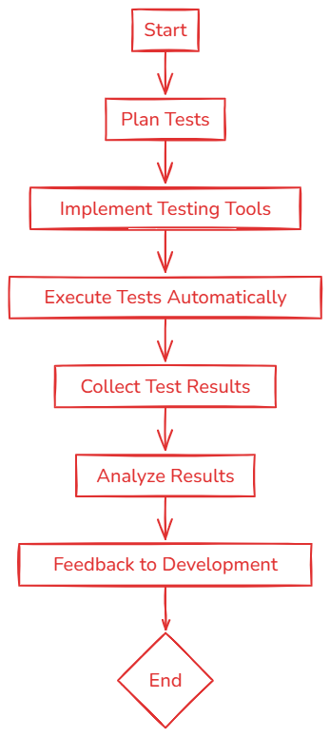

1. **Start**:
   * The process begins, marking the initiation of the testing cycle within the development process.
2. **Plan Tests**:
   * This stage involves planning the testing activities. It includes defining the scope of testing, determining which aspects of the software will be tested, scheduling test runs, and assigning responsibilities. The planning phase is crucial for aligning testing activities with the overall project timelines and objectives.
3. **Implement Testing Tools**:
   * Here, the necessary testing tools are selected and implemented. This could involve setting up Selenium for automated UI testing, JUnit for unit tests, and integrating these with a CI/CD tool like Jenkins. The choice of tools depends on the project requirements and the technologies used in the software development.

##### Execute Tests Automatically:

* + Automated tests are executed as per the plans made in the previous stages. This automation is typically integrated into the CI/CD pipeline, allowing tests to be triggered automatically on code commits, at scheduled times, or even manually. This step is critical for continuous testing, ensuring that any changes in the codebase do not introduce regressions or new bugs.

1. **Collect Test Results**:
   * After test execution, results are collected systematically. This data might include success or failure statuses, logs, screenshots, and other artifacts relevant to the tests. Efficient collection and organization of test results are vital for quick access and analysis.
2. **Analyze Results**:
   * The gathered results are analyzed to understand the quality of the software and the effectiveness of the tests. Analysis can help identify patterns in failures, areas of the software that are prone to issues, and potential improvements in the software or the testing process itself.
3. **Feedback to Development**:
   * Insights and issues identified from the test results are fed back to the development team. This step is crucial for continuous improvement, allowing developers to make informed decisions about where changes are needed, thereby enhancing the software's quality and reliability.
4. **End**:
   * The cycle completes, but in continuous testing environments, this often leads right back to the planning stage for the next set of tests, continuing the iterative nature of agile development practices.